

TUDU Milestone Awards
Internal Reference Document

1. Overview
Physical and digital rewards are mailed to hosts when they reach major hosting milestones, accompanied by a personalized letter. The program is designed to recognize host commitment with escalating prestige — from a first digital badge at 10 events, up to a lifetime-recognition trophy at 5,000+ events.

2. Milestone Tiers
Tier | Milestone | Award Type
Bronze Compass | Host 10 Events | Plaque
Silver Trailblazer | Host 50 Events | Plaque
Gold Adventurer | Host 250 Events | Plaque
Emerald Pathfinder | Host 1,000 Events | Crystal Trophy
Diamond Horizon Award | Host 5,000+ Events | Crystal Trophy

Bronze, Silver, and Gold tiers are presented as plaques. Emerald and Diamond tiers are presented as crystal trophies. Hosts may also purchase or redeem Miles for a physical award at the Bronze, Silver, or Gold tiers ahead of reaching that milestone naturally.

3. Tiered Digital Badges
Digital badges are awarded alongside each tier and can be displayed across the platform, including:
- Host profile
- Event cards
- Comments
- Search results
- Map pins

4. Physical Awards
Each host also receives a personalized award letter. Emerald Pathfinder and Diamond Horizon recipients receive a fully personalized, signed letter; earlier tiers receive a PDF congratulations letter.

Design concept — plaque style for early-tier awards (exact tier number to be finalized)
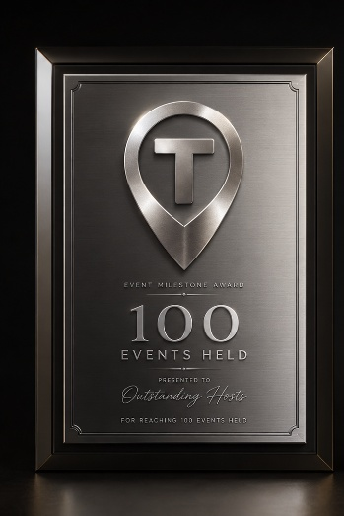

Design concept — crystal trophy tier award style (Emerald Pathfinder / Diamond Horizon)
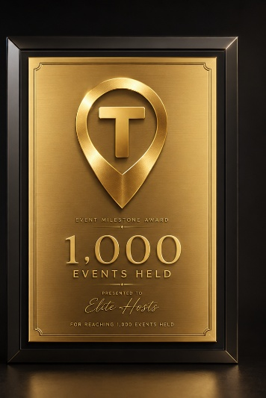

5. Tier Benefits

5.1 Bronze Compass — 10 Events
- 800 TUDU Miles ($1.00)
- Bronze digital badge
- PDF congratulations letter
- Option to purchase or redeem Miles for a physical trophy
Open question: Special graphic for social media — to be designed.

5.2 Silver Trailblazer — 50 Events
- 2,500 TUDU Miles ($3.12)
- Silver digital badge
- Profile banner upgrade
- Option to purchase or redeem Miles for a physical trophy
- PDF congratulations letter
- Priority bump (24 hours)

5.3 Gold Adventurer — 250 Events
- 5,000 TUDU Miles ($6.25)
- Gold digital badge
- Profile banner upgrade
- Option to purchase or redeem Miles for a physical trophy
- PDF congratulations letter
- Priority bump (48 hours)
- Thank-you video

5.4 Emerald Pathfinder — 1,000 Events
- 50,000 TUDU Miles ($156.25)
- Emerald digital badge
- Profile banner upgrade
- High-quality physical trophy
- Personalized, signed letter
- Invitation to the TUDU Hosted Annual Event
- 1 month of free Trusted Host

5.5 Diamond Horizon Award — 5,000+ Events
- 125,000 TUDU Miles ($625.00)
- Diamond digital badge
- Profile banner upgrade
- High-quality physical trophy
- Personalized, signed letter
- Lifetime invitation to TUDU Hosted Annual Events
- 1 year of free Trusted Host

